ODY Token contract audit

1)Errors and remarks in the code:

1. ODY Token seems like ERC-223 Token standard, but this standard is extended ERC-20. So it must include at least:
event Transfer(address indexed _from, address indexed _to, uint256 _value);
when you have only:
event Transfer(address indexed from, address indexed to, uint value, bytes indexed data);
Etherscan.io will not be able to recognize this contract as Token contract.

2. function getTokenAmount(uint weiAmount) internal view returns(uint) {
uint tokens = safeMul(weiAmount, RATE);
uint bonus;
// calculate bonus amount
if (isPreSale()) {
// 50% for pre ICO
bonus = tokens * BONUS_STAGE1 / 100;
} else {
if (weiRaised <= 2000 ether)
bonus = tokens * BONUS_STAGE2 / 100;
else if (weiRaised <= 4000 ether)
bonus = tokens * BONUS_STAGE3 / 100;
else if (weiRaised <= 6000 ether)
bonus = tokens * BONUS_STAGE4 / 100;
else if (weiRaised <= 14000 ether)
bonus = tokens * BONUS_STAGE5 / 100;
}
return safeAdd(tokens, bonus);
}
This function don’t use SafeMath and can be simplified to:
function getTokenAmount(uint weiAmount) internal view returns(uint) {
uint tokens = safeMul(weiAmount, RATE);

// calculate bonus amount
if (isPreSale()) {
// 50% for pre ICO
return tokens * BONUS_STAGE1 / 100;
} else {
if (weiRaised <= 2000 ether)
return safeMul(tokens,BONUS_STAGE2) / 100;
else if (weiRaised <= 4000 ether)
return safeMul(tokens,BONUS_STAGE3) / 100;
else if (weiRaised <= 6000 ether)
return safeMul(tokens,BONUS_STAGE4) / 100;
else if (weiRaised <= 14000 ether)
return safeMul(tokens,BONUS_STAGE5) / 100;
}
return tokens;
}

3. This function:
function _transfer(address _from, address _to, uint _value) internal returns (bool success) {
if (balanceOf(_from) < _value)
revert();
bytes memory empty;
balances[_from] = safeSub(balanceOf(_from), _value);
balances[_to] = safeAdd(balanceOf(_to), _value);
Transfer(msg.sender, _to, _value, empty); //This event isn’t correct. Msg.sender must be changed into _from
return true;
}

calling only with (_from == this), so it can be recognize like this:

function _transfer(address _to, uint _value) internal returns (bool success) {
if (balanceOf(this) < _value)
revert();
bytes memory empty;
balances[_from] = safeSub(balanceOf(this), _value);
balances[_to] = safeAdd(balanceOf(_to), _value);
Transfer(this, _to, _value, empty);
return true;
}
And in this realization it might be call something like sendFromThis or sendThisContractTokens, tokenPurchase. This function not really used as transfer.

4. All function like this:
if (balanceOf(this) < _value)
revert();
should be simplify:
require( balanceOf(this) >= _value);

in current version of Solidity compiler require and assert calling function revert();
proof:
https://ethereum.stackexchange.com/questions/15166/difference-between-require-and-assert-and-the-difference-between-revert-and-thro
------------------------------------------------------------------------------------------------------------------------
5. function release() onlyOwner public {
uint nextReleaseTime = MAIN_SALE_START + (teamFundReleaseIndex * 180 days);
require(now >= nextReleaseTime && teamFundReleaseIndex < 8);
_transfer(this, teamFundAddress, TEAM_FUND_RELEASE_AMOUNT);
teamFundReleaseIndex++;
}
in first iteration teamFundReleaseIndex = 0, so owner can use this function when now = MAIN_SALE_START

Maybe its correct, but I think that owner could use this function only when 180 days has already passed. So I would have done like this:
function release() onlyOwner public {
uint nextReleaseTime = MAIN_SALE_START + ((teamFundReleaseIndex +1) * 180 days);
require(now >= nextReleaseTime && teamFundReleaseIndex < 8);
_transfer(this, teamFundAddress, TEAM_FUND_RELEASE_AMOUNT);
teamFundReleaseIndex++;
}

6. Its about missing ERC-20 Token Standard
Its your contract code:

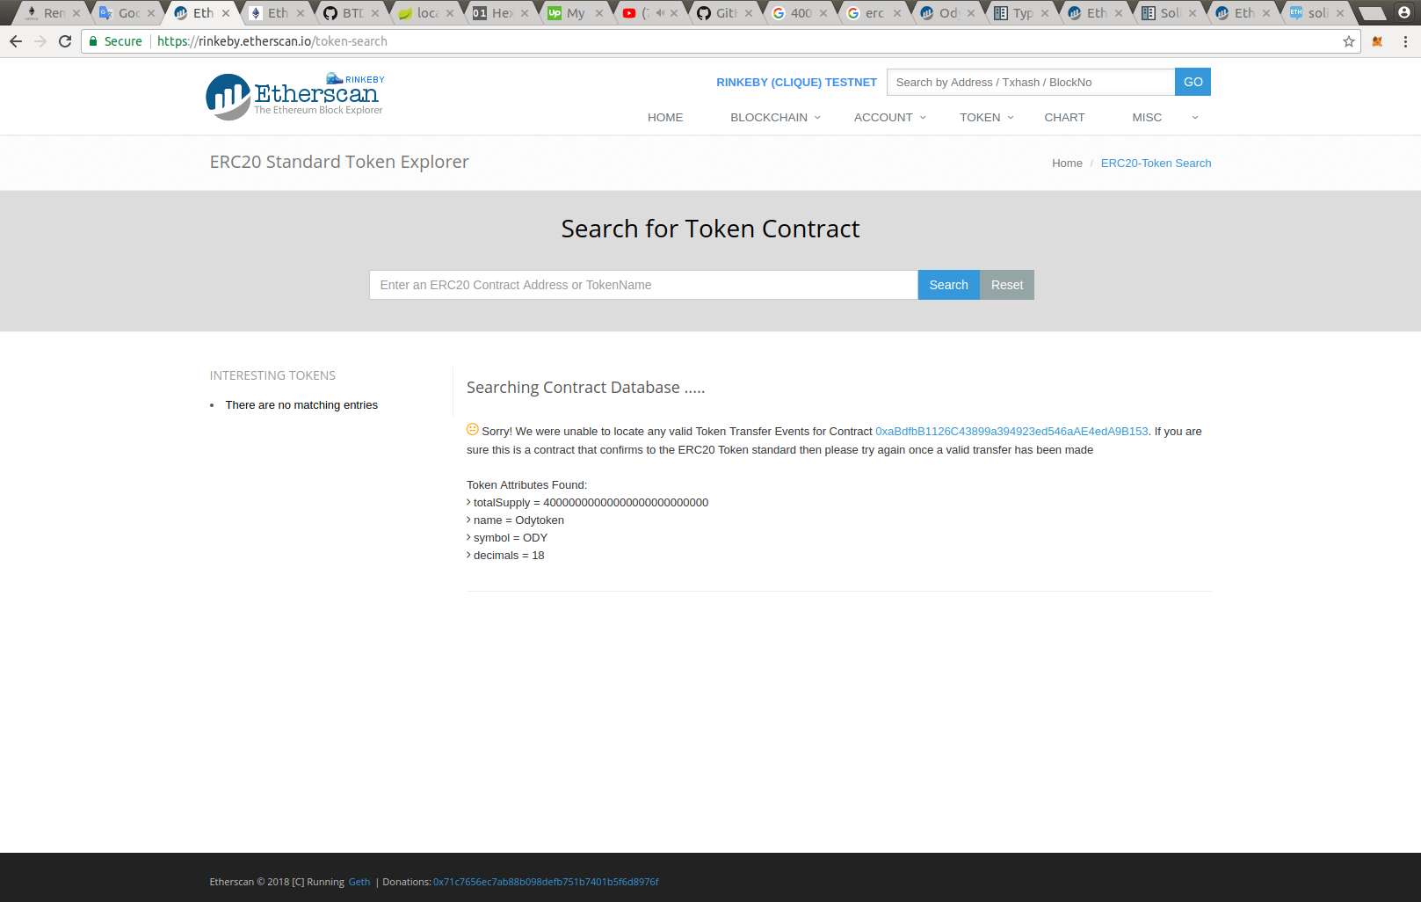

its your modified code with some changes associate with:
event Transfer(address indexed from, address indexed to, uint value);
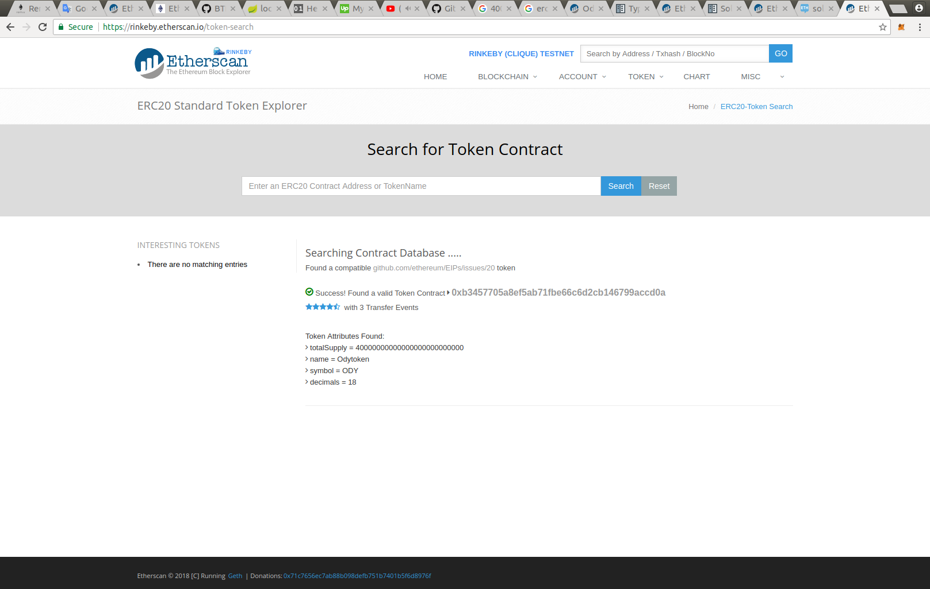
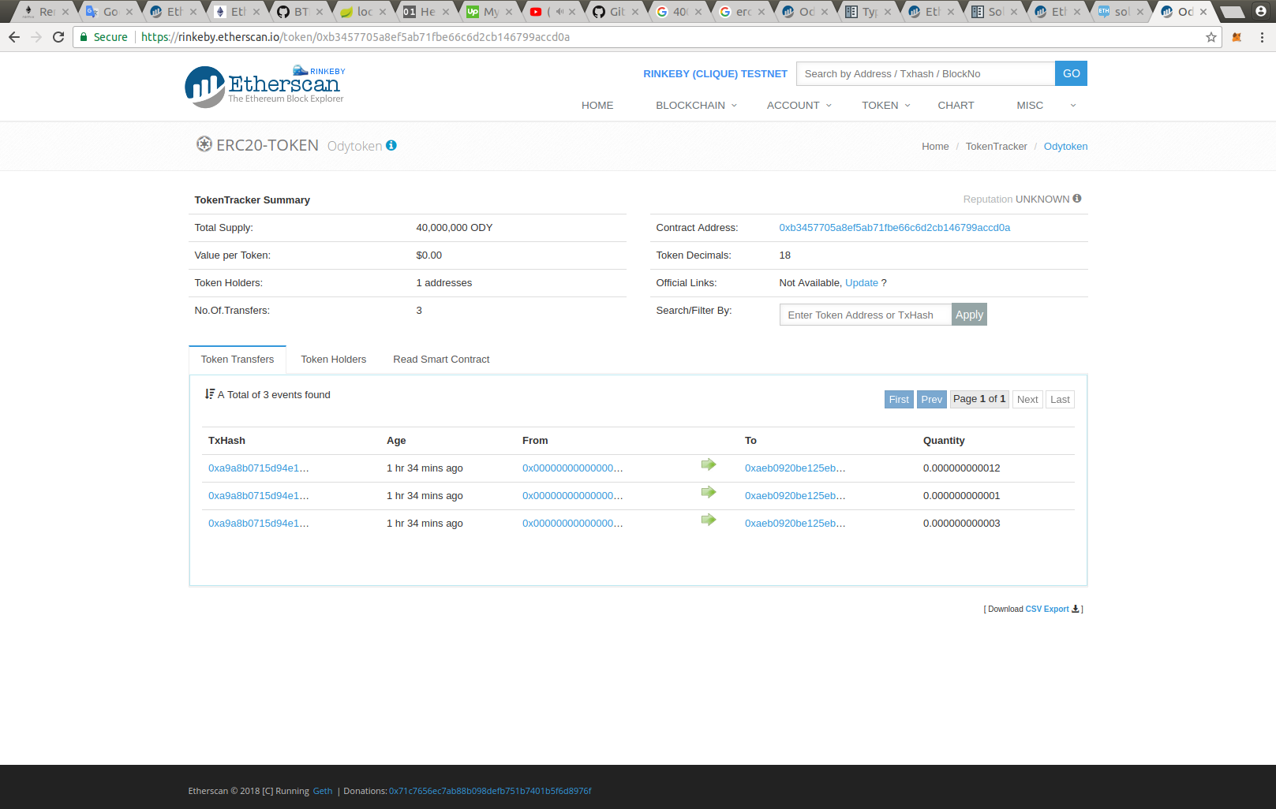

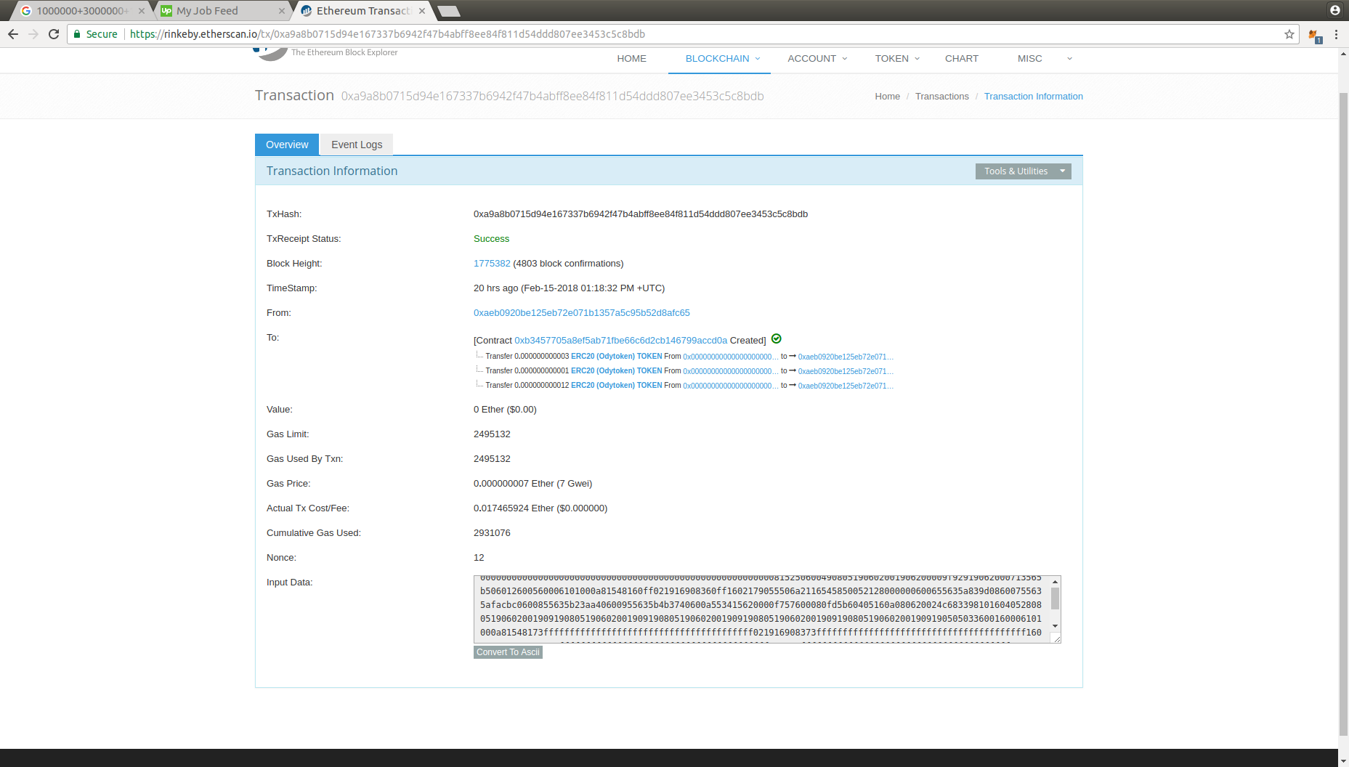
on the performance of the contract is not affected in any way, but I think that it would be better for the customer to see such a picture on Etherscan.io.

7. Unsold tokens are put in the reserve. Its technical task but I can’t find it realization. Also as function which must end ICO.

8. https://github.com/Dexaran/ERC223-token-standard/blob/Recommended/ERC223_Token.sol

when you change someone else's work, please change and comments too. Now its not his token contract:
/**
* ERC223 token by Dexaran
*
* https://github.com/Dexaran/ERC223-token-standard
*/

9. Idk why it public, make it private please.
uint256 constant public MAX_UINT256 = 0xFFFFFFFFFFFFFFFFFFFFFFFFFFFFFFFFFFFFFFFFFFFFFFFFFFFFFFFFFFFFFFFF;

10. In technical task you have softCap, which implies a return of funds if soft cap is not achieved, but ether transfer to owner in each transaction:

function () public payable {
// only accept a minimum amount of ETH?
require(msg.value >= MIN_VALUE && msg.value <= MAX_VALUE);

uint tokens = getTokenAmount(msg.value);

require(validPurchase(msg.value));
_transfer(this, msg.sender, tokens);
weiRaised += msg.value;

TokenPurchase(msg.sender, msg.value, tokens);
forwardFunds();
}
function forwardFunds() internal {
wallet.transfer(msg.value);
}

And this function using only in one place, so it can be recognize:

function () public payable {
// only accept a minimum amount of ETH?
require(msg.value >= MIN_VALUE && msg.value <= MAX_VALUE);

uint tokens = getTokenAmount(msg.value);
require(validPurchase(msg.value));
_transfer(this, msg.sender, tokens);
weiRaised += msg.value;
TokenPurchase(msg.sender, msg.value, tokens);
wallet.transfer(msg.value);
}
So, or remove the software or add refund option.

11. uint PRE_SALE_START = 1518574856; // 1523793600;
uint PRE_SALE_END = 1526385600;

// Date for main ICO: June 15, 2018 12:00 pm UTC to July 15, 2018 12:00 pm UTC
uint MAIN_SALE_START = 1529064000;
uint MAIN_SALE_END = 1531656000;
PRE_SALE_END = MAIN_SALE_START , in this case it’s not a problem, but for a future make 1second difference ( MAIN_SALE_START = 1529064001), can be some bugs with this, but not in this contract realization.

12. TokenPurchase(msg.sender, msg.value, tokens) event isn’t require for technical task. If you will use it with your site – keep it, else – remove.

13.

A variant of buying tokens at a mixed price was not developed. For example:
Now collected 1999 ETH and someone send to contract 50ETH, he will take 35% bonus. Maybe it’s Ok, but I must tell you about that.

14. function isContract(address _addr) private view returns (bool is_contract) {
uint length;
assembly {
//retrieve the size of the code on target address, this needs assembly
length := extcodesize(_addr)
}
return (length>0);
}
Take note about this part “returns (bool is_contract)”, you initializing variable which is not used anywhere. It would be more correct “returns (bool)”. And this is in almost all functions.

2)My opinion about the contract:

Contract almost corresponds to technical task not including some items:

1.Token type: ERC223
because ERC223 Token is modified ERC-20 standard, which isn’t completed. I think it’s major error because contract does not displayed at core resources as a Token contract.

2. Unsold tokens are put in the reserve.
This realization doesn’t present!!! I think it’s critical error because contract does not match to technical task.

3. The best practice is separate contracts for Crowdsdale and Token. When something wrong with Crowdsale, your Token will always be active. And you can redeploy just Crowdsale contact.
Its projection inaccuracy, which does not allow you to make your crowdsdale flexible.

4. Point 10 in the previous paragraph is major error because contract does not match to technical task.

5. No fatal errors, which can break this contract not found.

